Joseph Hutchinson

2024-02-14

Laboratory 4 (3 days):

**BJT characteristics, Small Signal Amplifiers**

**Material covered:**

* This laboratory has ***three sessions*** allocated for completion.

o **1st session: Pre-Lab Exercise 1 and Exercise 1**

o 2nd session: Pre-Lab Exercise 2 and Exercise 2 o 3rd session: Exercise 3 and Exercise 4

* BJT DC biasing, Forward active, reverse active, saturation
* Small signal models for BJTs
* Common emitter, common base, common collector configurations
* Small signal bandwidth

**Overview notes:**

*PSpice – Setting up DC Sweeps with a secondary sweep*

1. Select Simulation Profile and choose Primary Sweep
2. Indicate the source type, source name, start value, end value and increments. Make the increments sufficiently small that your plots look ‘smooth’
3. Select Secondary Sweep, checking the box on. Both Primary and Second Sweeps should have check marks in the associated boxes.
4. Again, indicate the source type, source name, start value, end value and increments.
5. After running the simulation, place an appropriate probe on the schematic and you will see plots of the probe type against the Primary Sweep variable. Each plot will correspond to a different Secondary Sweep step value.

***Note***: The DC biasing circuits for Exercises 4, 5 and 6 are the same. The resistors *R*1, *R*2, *R*C and *R*E comprise the DC bias resistors.

# Pre-Lab Exercise 1

***Note***: For the PSpice simulations, the transistors are Q2N2222 and for the experimental portion, the transistors are PN2222.

1. Build the circuit shown in Figure 1 (below) in PSpice. Both sources are of type VDC. Set *V*CE to 2 V and under the simulation profile set *V*BE to the Primary Sweep with voltage range

0 < *V*BE < 0.7 V. Generate a plot of *I*C-versus-*V*BE.

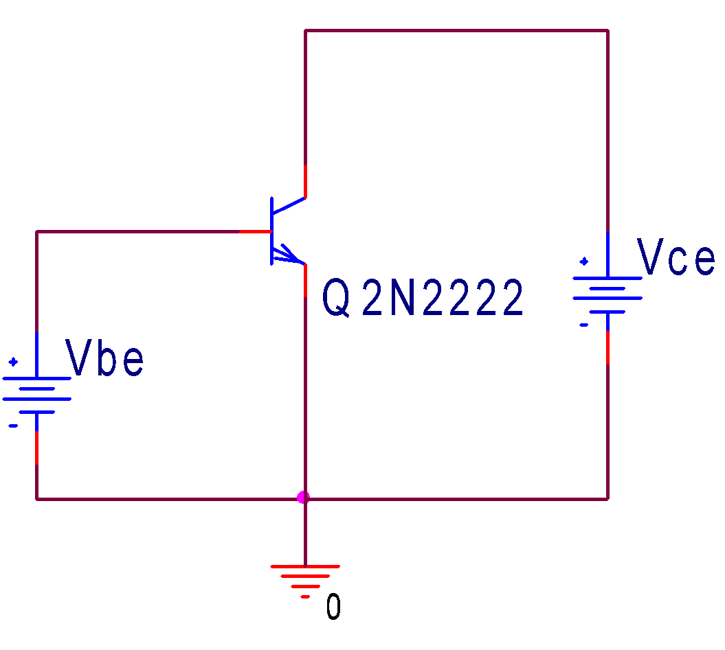

## Figure 1: BJT with voltage control

*On the plot, indicate the regions where the BJT is OFF and where it is ON.*

*Approximately, at what base-emitter voltage does the transistor turn ON. Is this consistent with diode characteristics?*

The transistor turns ON at a base-emitter voltage of ~0.7V. This is consistent with the characteristics for a silicon diode, which has a Vthreshold = 0.7V.

2. Change the Primary Sweep to *V*CE, setting the voltage range 0 < *V*CE < 2V. Set *V*BE to the

Secondary Sweep with voltages *V*BE → {0.6, 0.62, 0.64, 0.66, 0.68, 0.7 V} and plot

*I*C-versus-*V*CE.m

**Active Region**

**Saturation  
Region**

*On the plots, identify the saturation region and the forward active region. Approximately, at what voltage is the transition from saturation to forward active. Is this value approximately consistent with your expectations?*

The transition in the simulation is occurring at an unexpectedly low value, around Vce=0.2V. This value should be closer to 0.7V. For the grey line, where Vbe = 0.7V, it DOES take until around 0.7V for the curve to reach its full horizontal asymptote value.

But, in the real experimental case, we should expect 0.7V as the transition voltage.

# Exercise 1: Device characteristics

1. Construct the circuit shown in Figure 4 (below) using the +25 V channel on the E3631A power supply for *V*1. Set *V*1 to the DC voltage of 7 V.

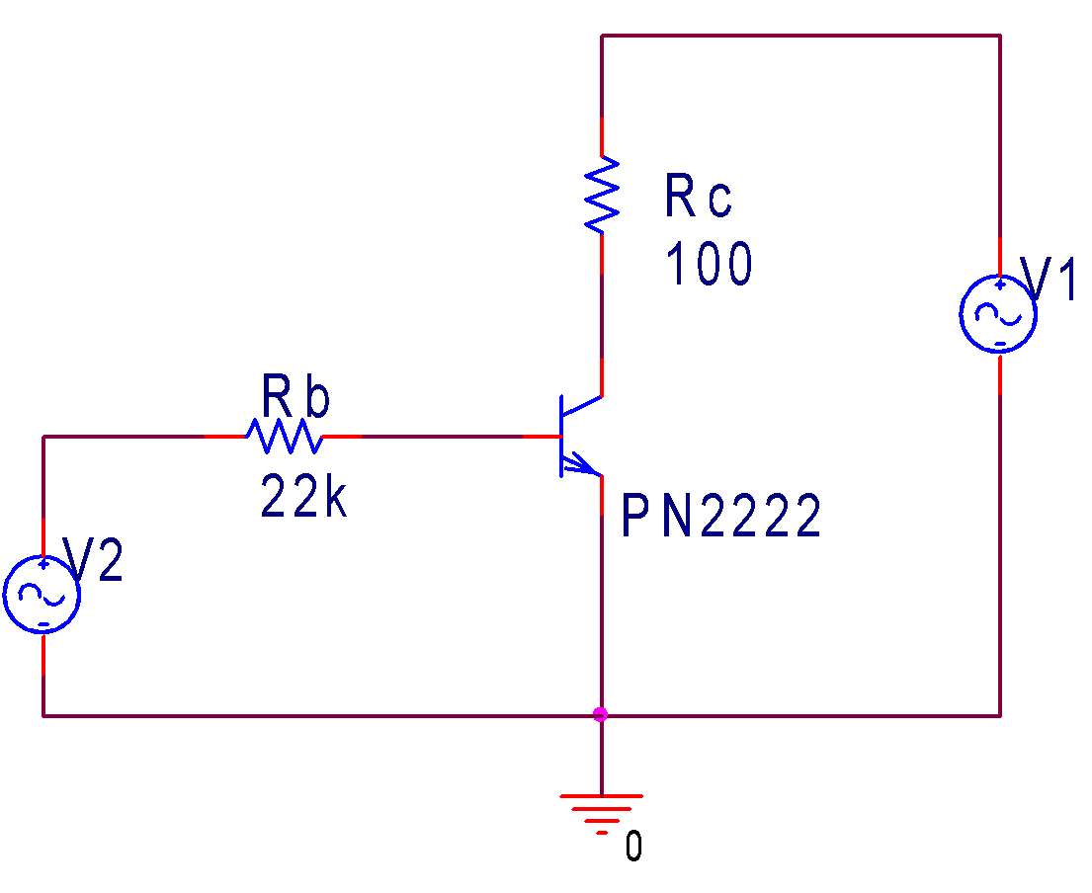

## Figure 4: BJT characteristics

*In the following, measure the DC voltages across and currents through (using Ohm’s law) R*C *and R*b. *Use the benchtop multimeter to make the DC measurements.*

1. Starting at *V* 2.0 V, slowly increase *V*2 until the BJT collector current *I*C is 20 mA. Determine the base current *I*B by measuring the voltage drop across the 22 kΩ base resistor. Measure *V*CE and verify that the device is in the forward active region. Measure *V*BE.

*Is the V*BE *measurement close to our 0.7 V approximation value?*

$$I_{C}=20 mA$$

$$I_{B}=\frac{V}{R}=\frac{\left(2.764-0.65\right)}{22kΩ}=0.09609 mA$$

Measured $V_{CE}=6.982 V$

Measured $V_{BE}=650 mV$

Yes, the measurement for $V_{BE}$ is close to our approximation of 0.7V, since we measured it at 650 mV.

1. At the voltage determined in Part 2 (above), use your *I*B and *I*C measurements to estimate the common-emitter current gain β = *I*C / *I*B.
2. Raise *V*1 to 10 V and measure *I*C , *V*CE and *V*BE.

*Describe the changes you see. Did V*BE *change significantly?*

$$I_{C}=\frac{V}{R}=\frac{}{}=21.6mA$$

$$V_{CE}=7.87 V$$

$$V_{BE}=622 mV$$

1. Use the two *I*C and *V*CE measurements to estimate the output resistance, *r*out , and the Early voltage, *V*Early. The Early voltage can be calculated from the formula (to be discussed during lecture):

$$Slope=\frac{ΔI_{C}}{ΔV_{CE}}=\frac{1}{r_{out}}=\frac{I_{C}}{V_{early}+V_{CE}}≈\frac{I_{C}}{V_{early}}$$

*How do these values compare to the spec sheet values for the PN2222?*

*Keep the transistor that you used in this exercise for the remaining exercises. If you lose your transistor, use the above circuit to determine the transistor characteristics for the replacement transistor. You will need the values for the small signal analysis.*